|  |  |  |  |
| --- | --- | --- | --- |
| **Fr. Conceicao Rodrigues College of Engineering Department of Computer Engineering** | | | |
| **Student’s Roll No** | **9603** | **Students Name** | **Zane Falcao** |
| **Date of Performance** |  | **SE Computer – Div** | **A** |

**Aim:** To study basics of Shell Scripting

**Lab Outcome:**

**CSL403.1: Demonstrate basic Operating system Commands, Shell scripts, System Calls and API wrt Linux.**

**Problem Statements:**

1.WAP that accepts user name and reports if user logged in.

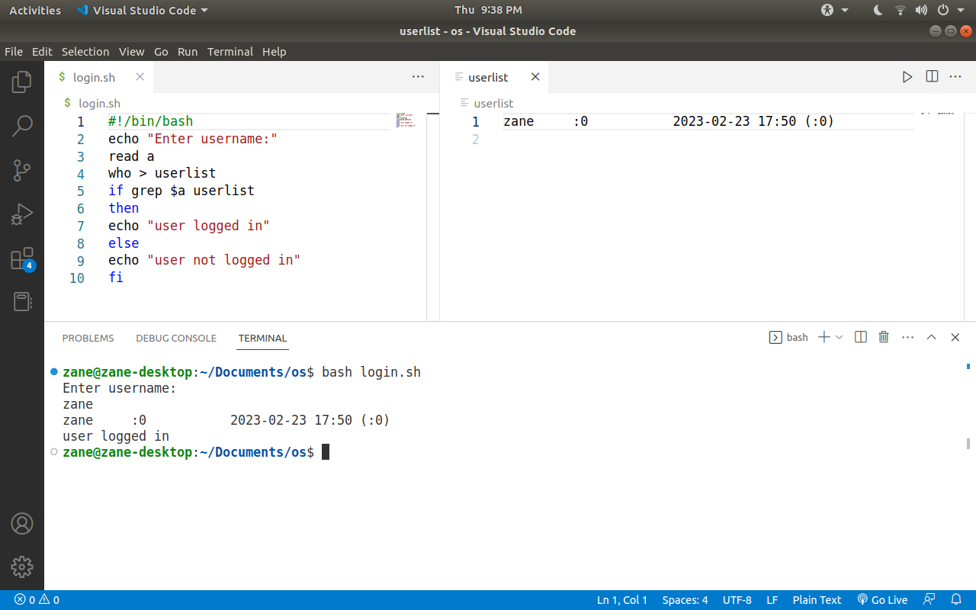

2.WAP that takes a filename as input and checks if it is executable, if not make it executable.

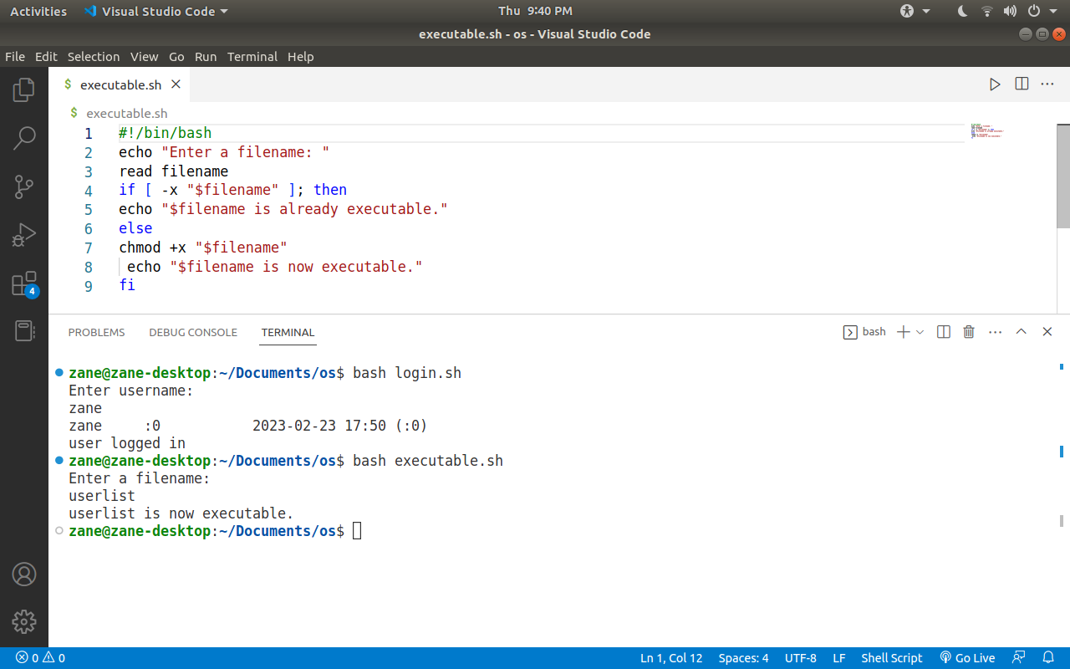

3.WAP to take string as command line argument and reverse it.

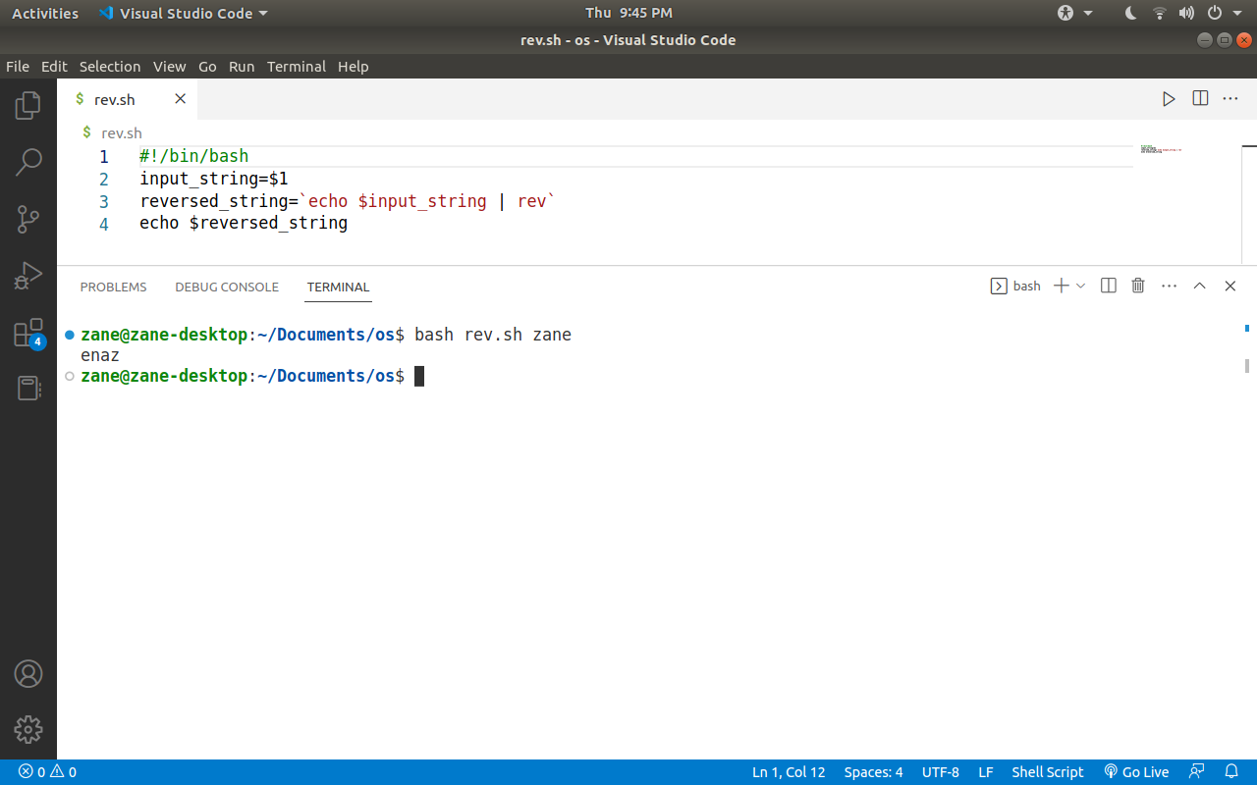

4.Write a shell script to find the sum, the average and the product of the four integers entered

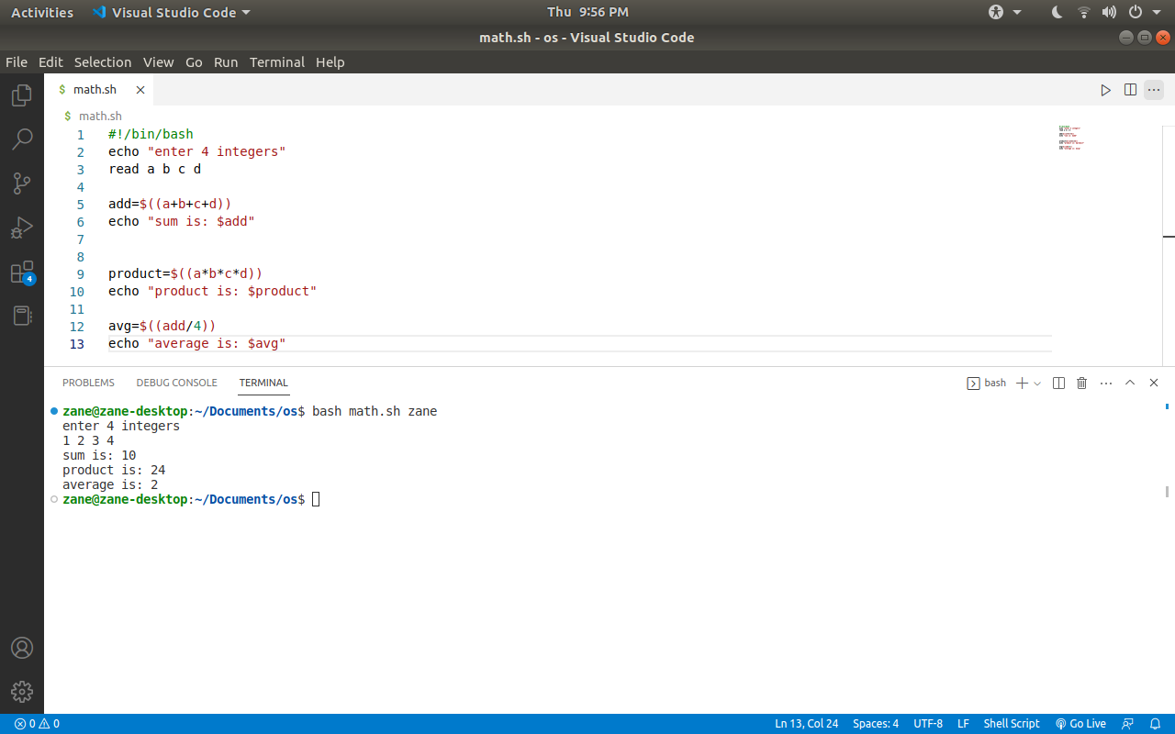

1. Write a shell script to find out the unique words in a file and also count the occurrence of each of these words. We can say that the file under consideration contains many lines, and each line has multiple words

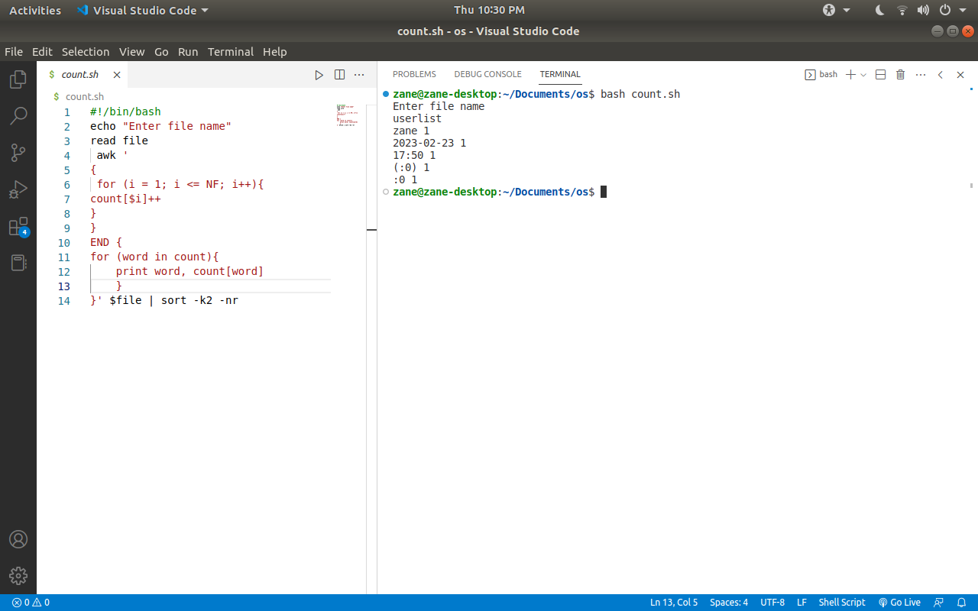

1. WAP which displays the following menu & executes the option selected by user: 1.ls 2.pwd 3.ls –l 4.ps -fe

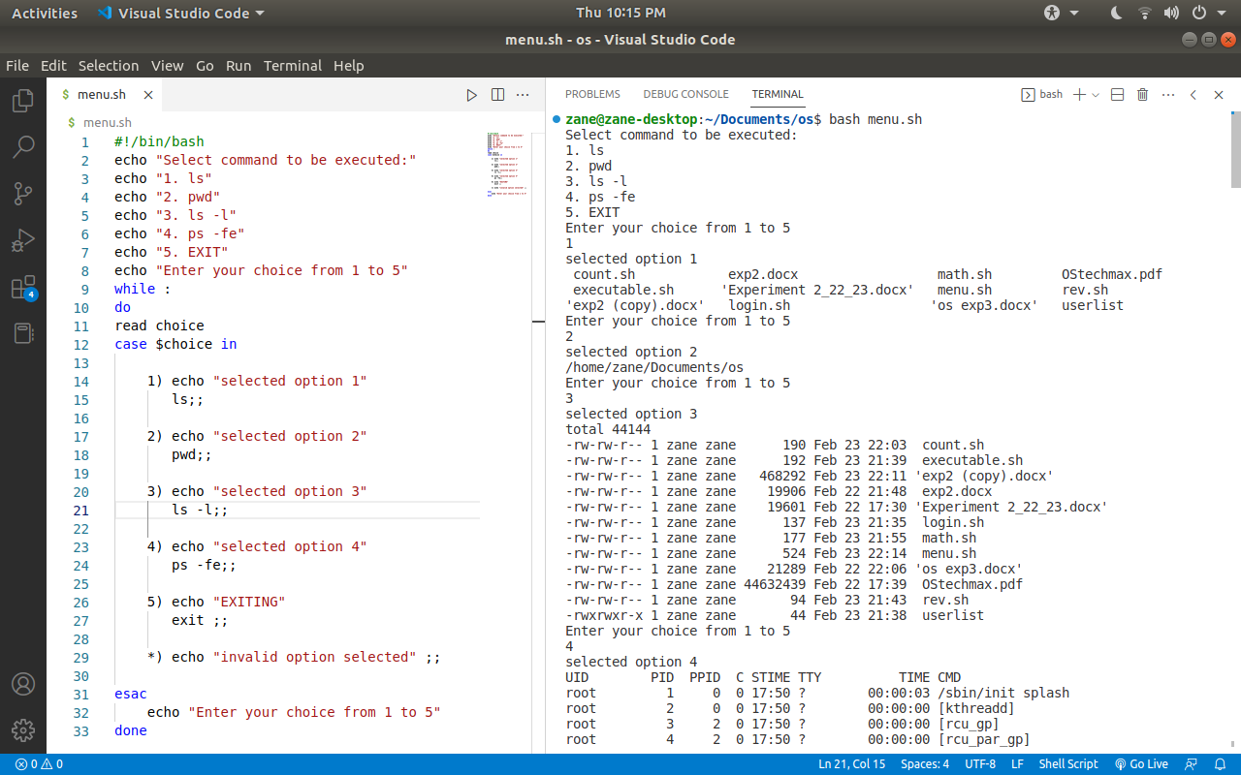

7.WAP that prompts user for a starting value & counts down from there.

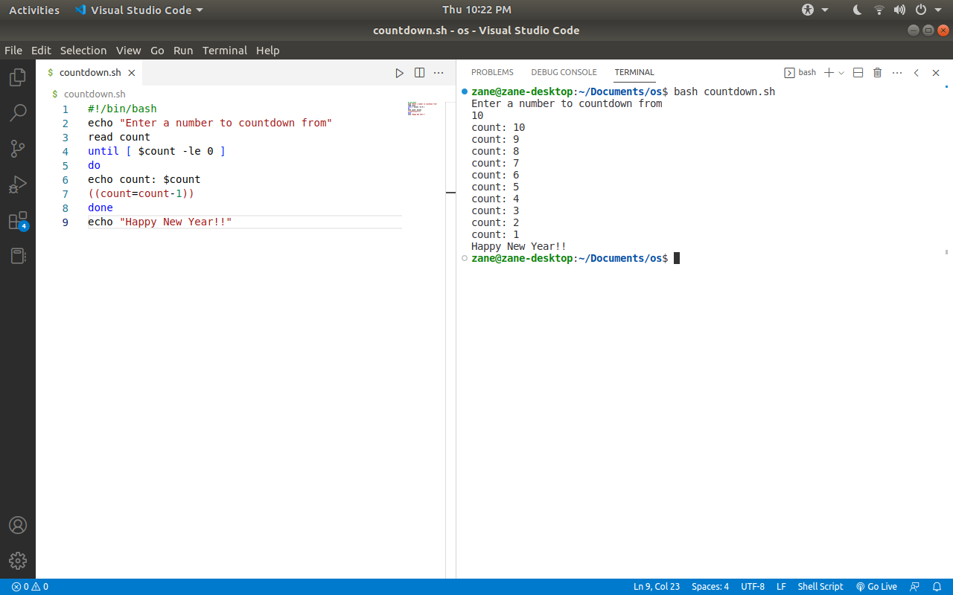

8.Create a data file called employee in the format given below:

EmpCode  Character, EmpName   Character , Grade  Character , Years of experience Numeric , Basic Pay   Numeric

* + Sort the file on EmpName.
  + Sort the file on

Decreasing order of basic pay

Increasing order of years of experience.

Display the number of employees whose details are included in the file.

Display all records with ‘smith’ a part of the employee name.

Display all records with EmpName starting with ‘B’.

echo "100,John James,A,5,25000

200,Sam Smith,B,7,30000

300,Zane ,C,4,20000

400,Ava Black,A,3,22000

500,Bridget Jones,B,6,28000

600,Sarah Green,C,5,24000" > employee

sort -k2 employee > sorted_employee

sort -k5,5nr -k4,4n sorted_employee > sorted_employee2

echo "Number of employees: $(wc -l < employee)"

grep 'Smith' employee

grep '^[^,]*,[B]' employee

OUTPUT:

zane@DESKTOP-LJHRUE9:~$ vim exp2.8.sh

zane@DESKTOP-LJHRUE9:~$ chmod +x exp2.8.sh

zane@DESKTOP-LJHRUE9:~$ ./exp2.8.sh

200,Sam Smith,B,7,30000

500, Bridget Jones,B,6,28000

300, Zane,C,4,20000

|  |  |  |  |
| --- | --- | --- | --- |
| **On time Submission(2)** | **Knowledge of Topic(4)** | **Implementation and Demonstration (4)** | **Total (10)** |
|  |  |  |  |
| **Signature of Faculty** |  | **Date of Submission** |  |